## LC3(Low Complexity Communication Codec ) codec intergration

主要讲怎么用LC3 对多channel做编解码，和如何传输已用LC3 编码的内容

### Introduction

LC3 is a single-channel codec. Any stereo or multi-channel coding is supported

The LC3 specification does not define a payload or transport format, 所以本文会讲

主要讲：

• A packet format for transporting LC3-encoded audio data

• The codec-specific parameter requirements for LC3

• The channel allocation – the mapping between Audio Channels and Audio Locations

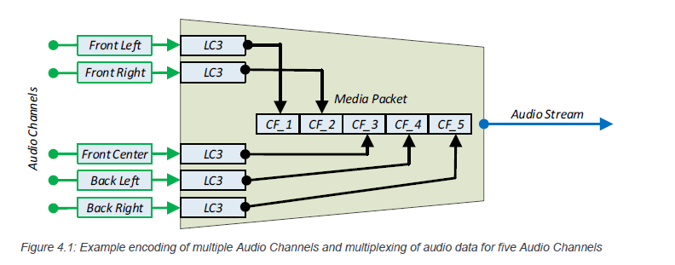

### LC3 Media Packet format

The LC3 Media Packet format has one field: the Payload field containing blocks of codec frames.

Payload 包含：

LC3 codec frame per Audio Channel per block

The number of LC3 codec frames,m,由Audio_Channel_Allocation LTV 决定

The number of blocks, n,由Codec_Frame_Blocks_Per_SDU LTV 决定

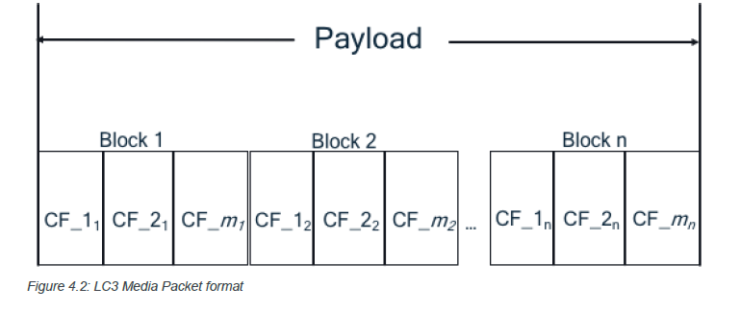

### LC3 LTV requirements

#### Codec_Specific_Capabilities LTV requirements

Devices exposing support for the LC3 codec shall follow the requirements in this section when populating the Codec_Specific_Capabilities field in PAC records

Codec_Specific_Capabilities field 应该包括：

Supported_Sampling_Frequencies

Supported_Frame_Durations

Supported_Audio_Channel_Counts， 可选， 缺失代表值为1

Supported_Octets_Per_Codec_Frame

Supported_Max_Codec_Frames_Per_SDU， 可选， 确实代表值为1

#### Codec_Specific_Configuration LTV requirements

配置音频流所需的LTV：

Sampling_Frequency

Frame_Duration

Audio_Channel_Allocation， 缺失代表这通道无指定位置的音频，single channel with no specified Audio Location

Octets_Per_Codec_Frame，

Codec_Frame_Blocks_Per_SDU， 跟前面的对每个块，块下面每帧对应起来

#### Metadata LTV requirements（可选）

有的话，需要设置：

Preferred_Audio_Contex， 缺失代表no preference for audio data Context Types defined in that PAC record.

Streaming_Audio_Contexts， 缺失代表不指定， the bit defined as unspecified set to a value of 0b1 and all other bits set to a value of 0b0.

Example 参考p50

### Multiple-channel LC3 unicast audio

P52 列出了所有多信道单播设备对LC3 的支持

一条线代表一路cis，一路cis 可以最多传输2 个单播音频流

箭头代表音频位置，左声道，右声道，立体声之类

ii 代表一个client 两个server

p53 是p52 的续表，列出音频配置要求，4.4 详细列了每一种场景

### Multiple-channel LC3 broadcast audio

P77 列出多信道广播对LC3 的支持

一条线代表一路bis

一个箭头代表一条channel,

BASE 的结构，p36

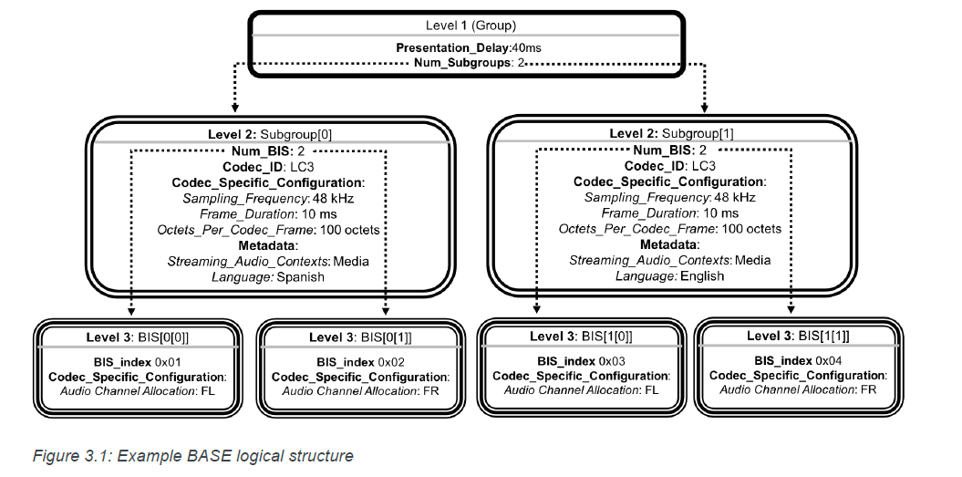

## Broadcast audio streaming procedures

前情回顾：

Audio announcements：

1. Broadcast Audio Announcements : inform scanning devices that a periodic advertising train (PA), transmitted by the device that transmits the Broadcast Audio Announcement, is associated with a BIG that transports one or more broadcast Audio Streams.
2. Basic Audio Announcements expose broadcast Audio Stream parameters.

Broadcast_ID：generated by source，shall not change for the lifetime of the BIG.

### Broadcast Audio Streams and advertising PDUs

EA 和PA前情回顾:

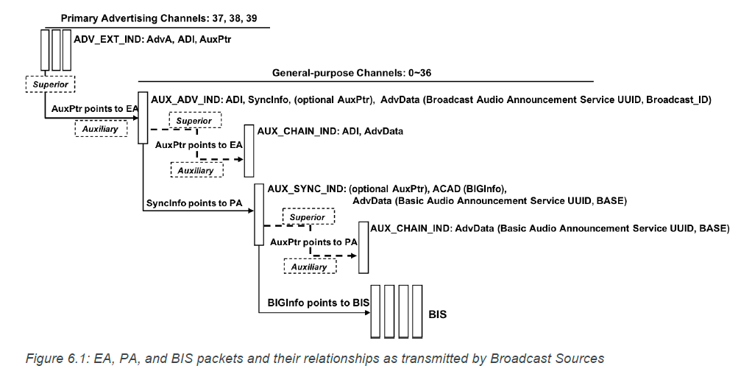

EA的重点是：

1. Broadcast Audio Announcement Service UUID， 包含BIG， BIS 信息
2. Broadcast_ID， The Broadcast_ID assists scanning devices that are not using a Filter Accept List [9] to determine that the EA points to the PA that points to the BIG of interest
3. Advertising Set ID, 从一个EA 出来的所有广播， 这个值会被写到ADV_EXT_IND和AUX_ADV_IND的Extended Header field 下面的ADI（AdvDataInfo就是用来鉴别SID的） 区域
4. 如果要使用AUX_CHAIN_IND，AUX_ADV_IND PDU 下面的AuxPtr 需要enable sync AUX_CHAIN_IND 的属性，并且要point这些AUX_CHAIN_IND PDU

PA 的重点

1. 如果要使用AUX_CHAIN_IND，AUX_SYNC_IND PDU 下面的AuxPtr 需要enable sync AUX_CHAIN_IND 的属性，并且要point这些AUX_CHAIN_IND PDU
2. AUX_SYNC_IND 和 AUX_CHAIN_IND 可以携带：

Service Data AD， 如果携带，会包含Basic Audio Announcement Service UUID 和可以描述音频配置的BASE

ACAD: 包含BIGInfo，可以enable sync, 接收音频流，point BIG

Device address recommendations for Broadcast Sources（对source 地址的建议）

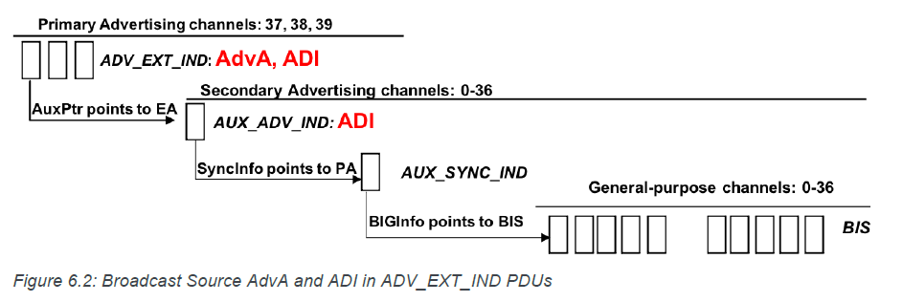

1. 在一个BIG 生命周期内，不要改变地址， 否则会sync lost
2. If using a random device address, the Broadcast Source should use a non-resolvable private address,
3. 使用resolvable private address 的唯一条件是，source 跟BA 共存于一个设备，P110，source 发现sink scan 了自己以后，应该关掉EA

### Broadcast Audio Stream state management

The Broadcast Source communicates using Basic Audio Announcements in the form of the BASE structure， 由source 进行传输

下图的配置是针对source的

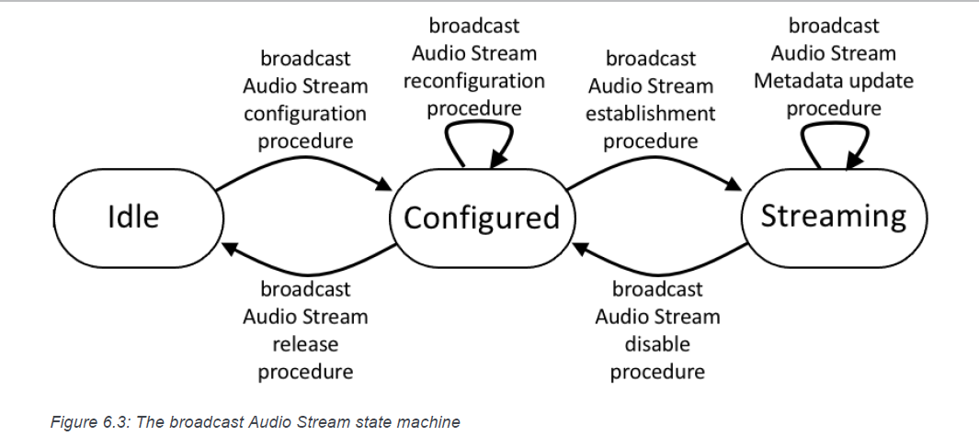

P111

Idle： 不传任何stream

Configured:

1. 配置好自己的controller， 准备发stream
2. 发带Broadcast Audio Announcements 的EA，PA
3. 发带Broadcast Audio Announcements 的PA， PA 不能带BIGInfo
4. BIG 不能带audio data

Streaming:

1. The broadcast Audio Stream is established on the Broadcast Source.
2. 发带Broadcast Audio Announcements， Broadcast_ID 的EA
3. 发带Broadcast Audio Announcements 的PA， PA 要带BIGInfo
4. 可以在BIG 里面发control parameters

### Broadcast Audio Stream configuration

配置内容：p113

Codec

metadata

other configuration parameters（Streaming_Audio_Contexts，）

也会对LL 进行配置：

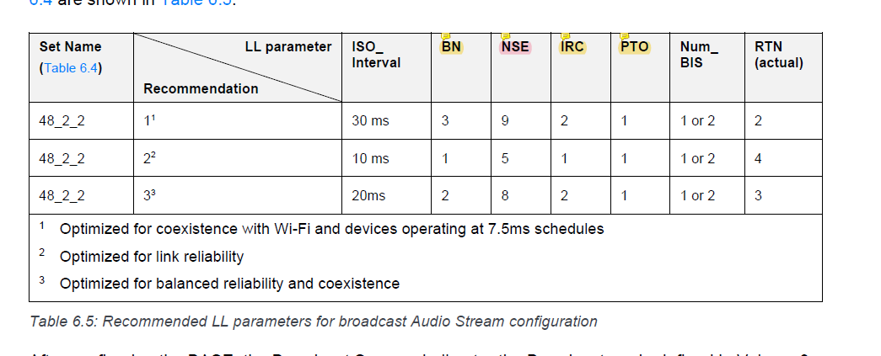

The Broadcast Source shall then enter the Periodic Advertising mode defined and transmit the configured BASE information in the AdvData field of AUX_SYNC_IND and/or AUX_CHAIN_IND PDUs.

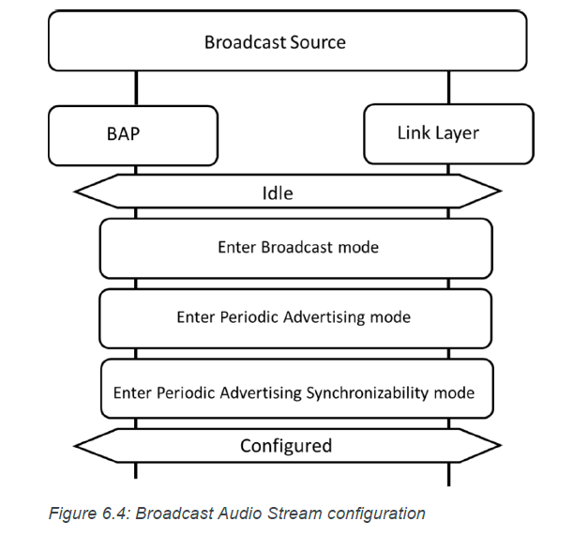

#### Broadcast Audio Stream reconfiguration

1. 在configured 状态下，可随时重配
2. 可以任意写Metadata parameter
3. 可以在Metadata parameter 里面包含Streaming_Audio_Contexts LTV
4. 配好了更新下BASE

#### Broadcast Audio Stream establishment

可以通过etablish audio stream 建立或者恢复broadcast Audio Stream transmission

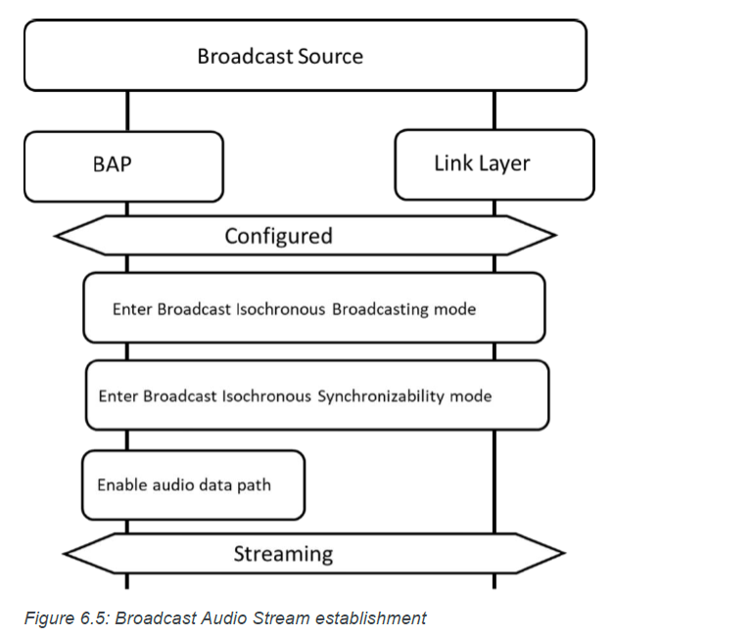

#### Broadcast Audio Stream Metadata update

随时更新，但是在streaming 的状态不能更新除了data length 和 data parameter 以外的BASE 参数

#### Broadcast Audio Stream disable

暂停后回到configured 状态，接着发带BAA 的PA， 允许应用重新传输

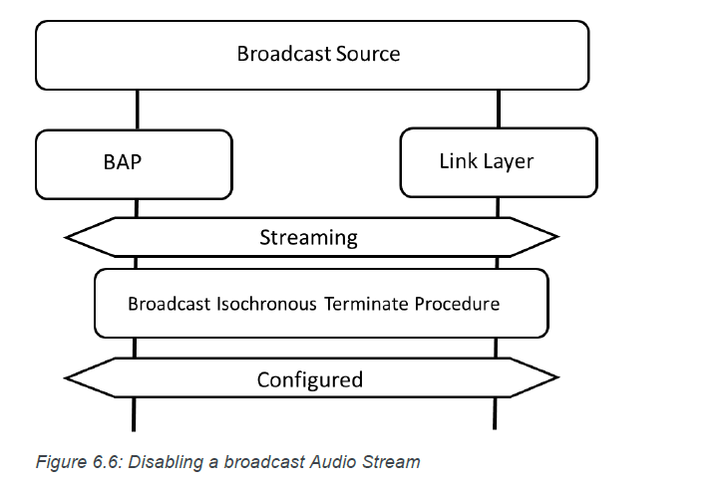

#### Broadcast Audio Stream release

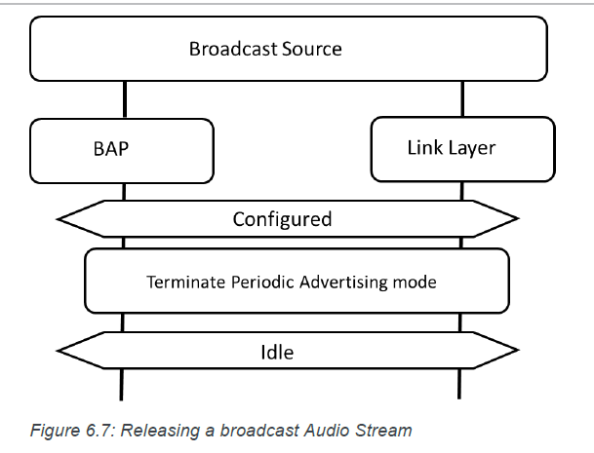

### Basic Audio Announcement discovery

Source 发Basic Audio Announcements， sink 或者BA discover， 流程：

1. EA 的Broadcast Audio Announcement service uuid 携带Service Data AD data， Broadcast_ID
2. PA 的syncinfo data enable sync

The PA contains the Service Data AD data type and contains the Basic Audio Announcement Service UUID and the BASE configuration.

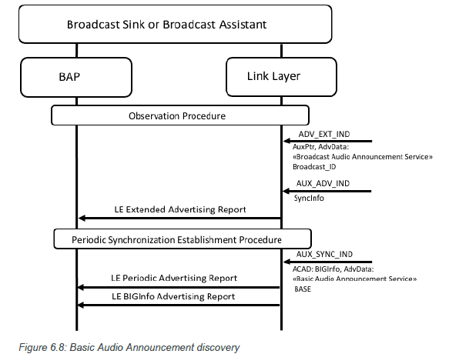

### Broadcast Assistant procedures

内容:

1. how a Broadcast Assistant can discover audio capabilities of Broadcast Sinks collocated with Scan Delegators
2. how a Broadcast Assistant can initiate Broadcast Audio Scan Control Point [6] operations with a Scan Delegator.

Delegator 要么单独存在，要么跟sink 一起存在

BA 要么单独存在，要么跟source一起存在

Delegator 存在是为了省电， 它可以从BA收到:

1. information from Broadcast Assistants that describes BIS，PAST 的流程
2. decryption keys necessary to decrypt encrypted BISes
3. known as Broadcast_Codes

BA 的能力：

1. BA 与source 在同一设备时，BA 能告知自己source 跟别的source 的信息，p121
2. BA can request the Scan Delegator to add, update, or remove information about broadcast Audio Streams by writing values defined in [6] to the Broadcast Audio Scan Control Point characteristic.
3. BA 能通过读取或者收delegator 的通知的Broadcast Receive State characteristic，知道delegator知道什么广播，避免写重

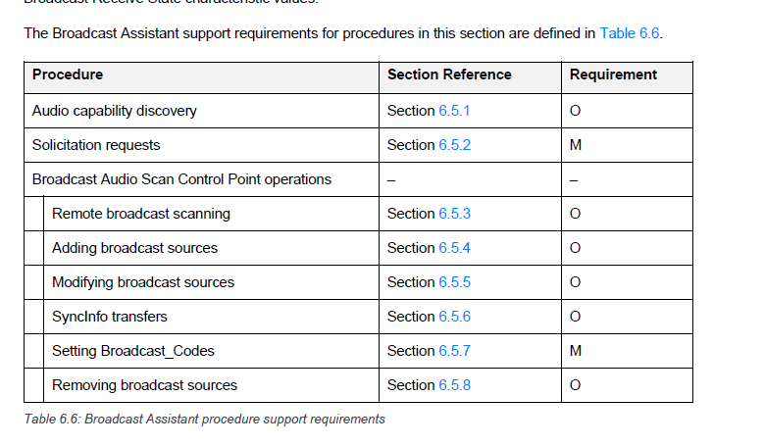

#### Audio Capability Discovery

发现delegator 的capabilities，知道它有能力接收和解码什么stream

may read the value of Sink PAC characteristics

may read the value of the Sink Audio Locations characteristic

#### Solicitation requests

Delegator 用EA 发送请求广播，BA 会扫带有Service Data AD 和Broadcast Audio Scan Service UUID 的EA

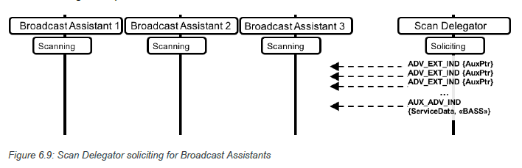

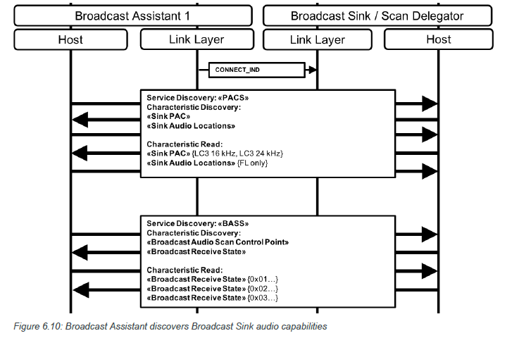

#### Remote broadcast scanning

BA initiate the Remote Scan Started or Remote Scan Stopped 告诉Delegator， 自己开始或停止扫描

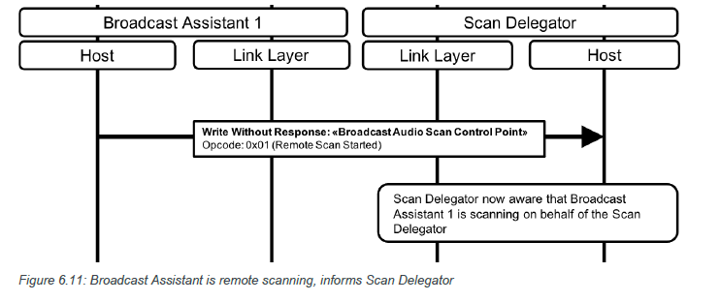

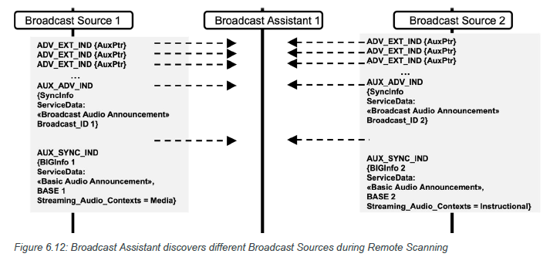

#### Adding broadcast sources

BA 不执行Add Source 的情况：

1. 先读对方的Broadcast Receive State characteristic， 发现Source_Address_Type, Source_Adv_SID, and Broadcast_ID fields 有一致的
2. 对方没有解码该音频流的能力

Add Source 添加Advertising_Address_Type, Advertiser_Address, Advertising_SID, Broadcast_ID, PA_Sync, PA_Interval, and Num_Subgroups（shall also write values for the BIS_Sync[i], Metadata_Length[i], and Metadata[i]）

写Advertiser_Address 需要注意：

1. Broadcast Assistant is collocated with the Broadcast Source， 有RPA 的话， 把RPA写入，delegator 本地应该存入source 的IRK， 可以根据RPA 的PRAND 与IRK 计算hash， 得到的值应该跟RPA 的hash 一致，RPA= HASH+prand
2. Broadcast Assistant is not collocated with the Broadcast Source， 如果地址类型是RPA，BA 应该先读source 的RPA
   1. 如果RPA更新，BA用add source 加个新的地址
   2. 如果RPA 没更新， BA should write an Advertiser_Address of all zeros.
3. 如果不是RPA，BA 应该写AdvA

BA 写PA_Sync 为0x01代表BA 支持PAST

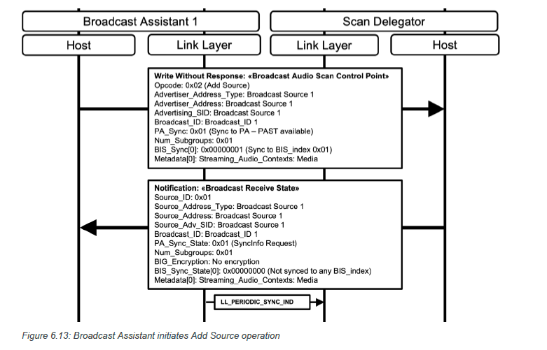

#### Modifying broadcast sources

需要改的值：Source_ID, PA_Sync, PA_Interval, and Num_Subgroups（BIS_Sync[i], Metadata_Length[i], and Metadata_Length[i]）

#### SyncInfo transfers (scan offloading)

BA transfer the SyncInfo data to Broadcast Sink collocated with the Scan Delegator

BA 自觉去读或者接收delegator 的SyncInfo request 的值是否为1， 决定是否ST, 置位之前绝不ST

PAST 流程完成标志是The PAST Broadcast Assistant has sent an LL_PERIODIC_SYNC_IND PDU to the Scan Delegator.

根据P127， 无论BA 写PAST available 与否，或者就算BA 不要求delegator sync， BA 只要支持PAST， 都可能会发起PAST

初始化PAST 的时候，写进去的AdvA 就是EA 的AdvA，不是的唯一情况是：

1. Source 改地址了
2. BA 用的地址就是同一个IRK生成的RPA地址，方便delegator 解析

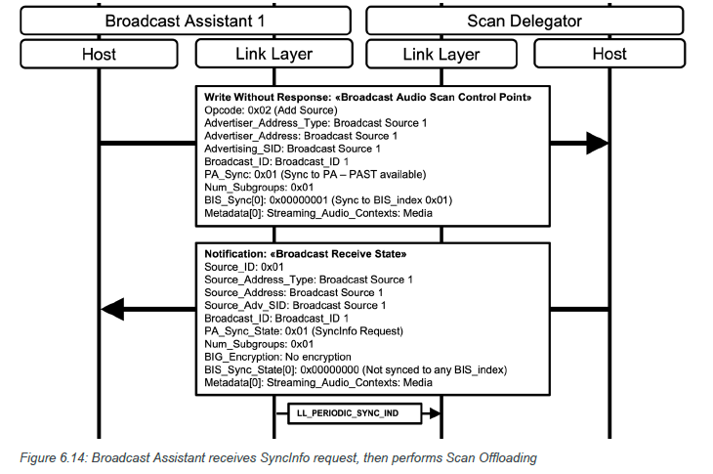

#### Setting Broadcast_Codes

Delegator 需要Broadcast_Code to decrypt a broadcast Audio Stream时， 会通知BA或者BA 主动读，BIG_Encryption field 的值时0x01 (Broadcast_Code required)

用BIG_Encryption field 为0x03（incorrect Broadcast_Code），通知BA

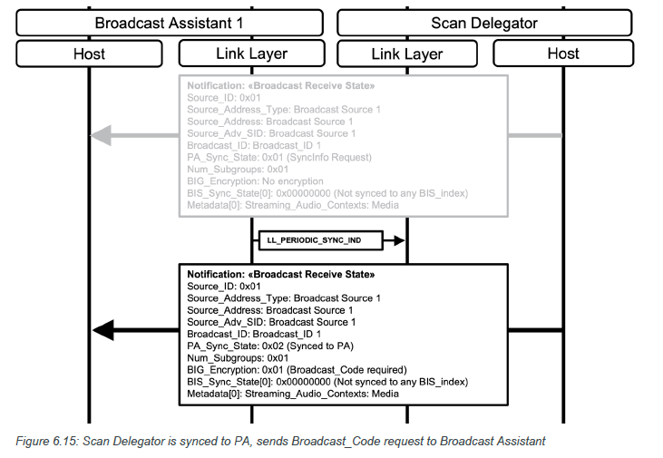

BA 会Set Broadcast_Code

如果是BA+delegator 的情况， 自己的code 被其他的BA 告知也是有可能的

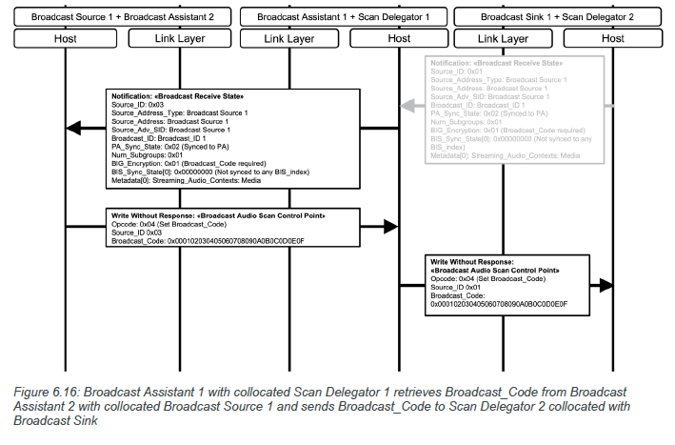

#### Removing sources

把BS 移除的为唯一条件是BA 发现BD 不再sync

### Broadcast Audio Stream synchronization

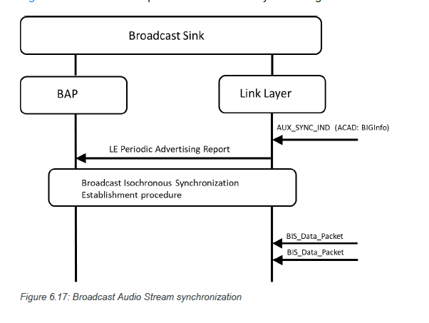

## Presentation delay and total system delay

### Presentation_Delay

存在的意义是多设备传输或者接收音频同步

单播会对所有ASE设置同一个Presentation_Delay，应用于unicast server

广播会对所有BIS 设置同一个值，应用于sink

#### Presentation_Delay for audio data reception by a Unicast Server and/or Broadcast Sink

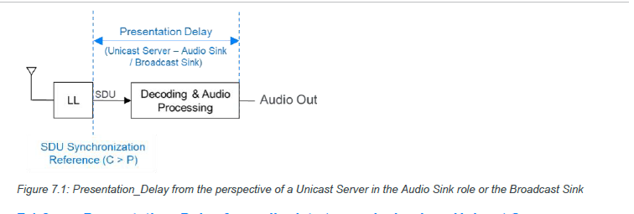

#### Presentation_Delay for audio data transmission by a Unicast Server

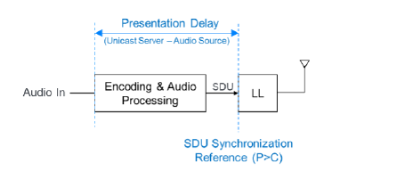

Selection of the Presentation_Delay_Min and Presentation_Delay_Max parameter values

两个值会在configured state 呈现，

根据Table 5.2 设置Presentation_Delay

### Total system delay

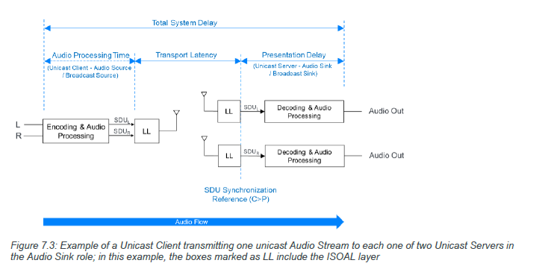

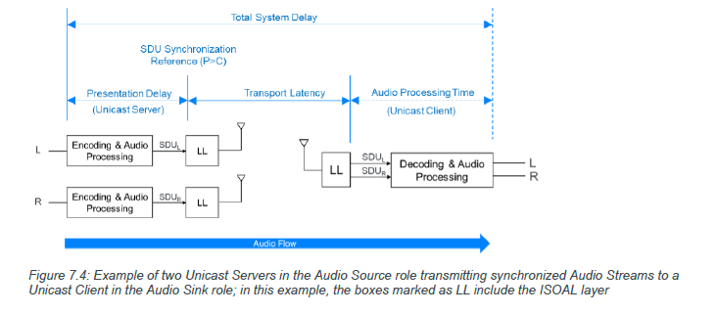

#### Selection of the Max_Transport_Latency parameter value

Codec Configured state 就定了Max_Transport_Latency

对unicast 来讲，sink 的最大传输延迟跟source的是两个值

单播客户端在配置Qos时设置最大传输延迟

客户端要求的最大传输延迟不能大于服务端暴露的值， sink source 同理